Healthy Weight Pathway for health professionals in County Durham

I am a health professional working in/ across GP practices in County Durham.
How can I effectively help my patient to achieve their health goals?
- Signpost and encourage to adopt the behaviours which promote healthy weight
- Referral into the most appropriate weight management programme/service for the patient

Healthy Weight Pathway
I want to know what support there is for my patient | Healthy Weight Pathway resource | 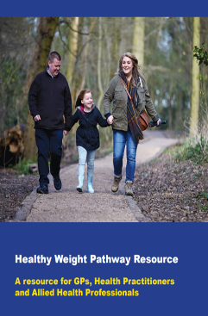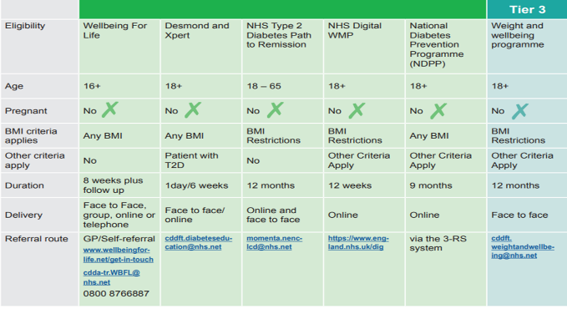
Healthy behaviours for healthy weight digital template

In the time available I want to be sure I can effectively help my patient | Brief Intervention Guide | 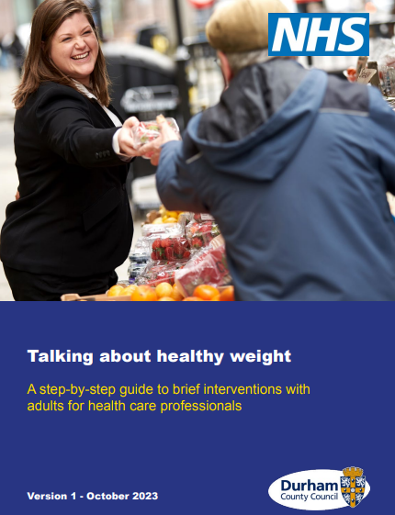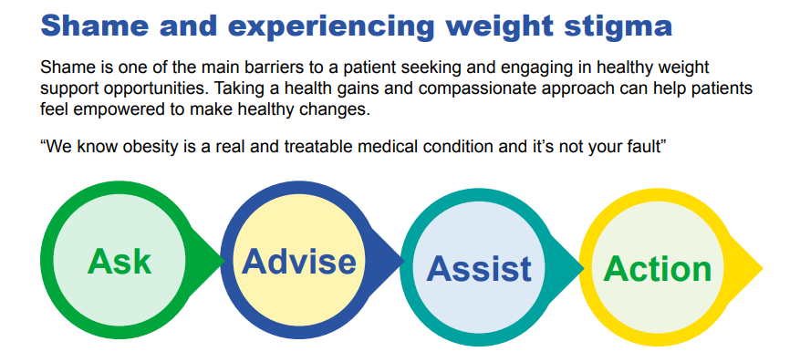
My patient wants help with healthy eating  Moving towards healthier | Dietary advice prompt guide | 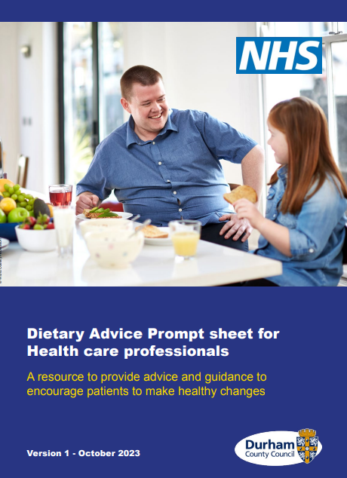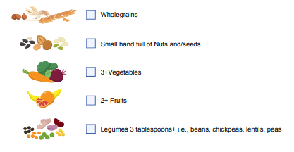
My patient has Type 2 Diabetes or prediabetes.  How can I help?  Dietary changes can bring them to remission status | Smarter Carbs guide  Eating well with Type 2 diabetes | 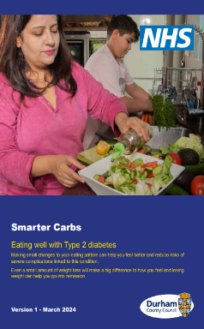  Reduce and limit added sugar  Lower starchy carbohydrates  Increase fibre  Protein is key  Healthy swaps

Where can I find these resources?
InstantAtlas Durham – Healthy Weight (durhaminsight.info)
To ensure we are all using the current version please use the following links from the Durham Insights page:

https://www.durhaminsight.info/wp-content/uploads/2024/08/56467-Healthy-Weight-Pathway-booklet.pdf

https://www.durhaminsight.info/wp-content/uploads/2024/08/55429-AHS-Healthy_weight_brief_intervention_guide_for_GPs__health_care_professionals_ACCESSIBLE.pdf

https://www.durhaminsight.info/wp-content/uploads/2024/08/55569-AHS-Brief_diatary_advice_guide_ACCESSIBLE.pdf

https://www.durhaminsight.info/wp-content/uploads/2024/08/56203-AHS-Smarter_carbs_ACCESSIBLE.pdf

https://www.durhaminsight.info/wp-content/uploads/2024/08/55546-AHS-Healthy_weight_advice_easy_read_ACCESSIBLE.pdf

Tier 3 and 4
Weight and Wellbeing programme
cddft.weightandwellbeing@nhs.net
Healthy Weight Pathway
Tier 1
Signposting to local and national
Healthy Weight Pathway

Tier 2
Check the weight management programmes, criteria and referral routes
Healthy Weight Pathway

